Ron Higgins

for
State Superintendent
of Public Instruction

- Certificated Teacher
- University of Washington Graduate
- Marine Corps Vietnam Veteran
- Conservative Pro-Life Activist
- Husband and Father

As Superintendent, I will:
- Oppose Comprehensive Sex Ed and any curriculum that sexualizes children;
- Protect local control and parental rights, including the right to homeschool;
- Emphasize academics (communication, computation, and civics);
- Protect the health, safety, and Constitutional rights of students and parents;
- Promote common sense, not common core
- Provide education, not indoctrination

Pro-Life. Pro-Family. Pro-Property Rights. Pro-2nd Amendment. Pro-Free Enterprise.

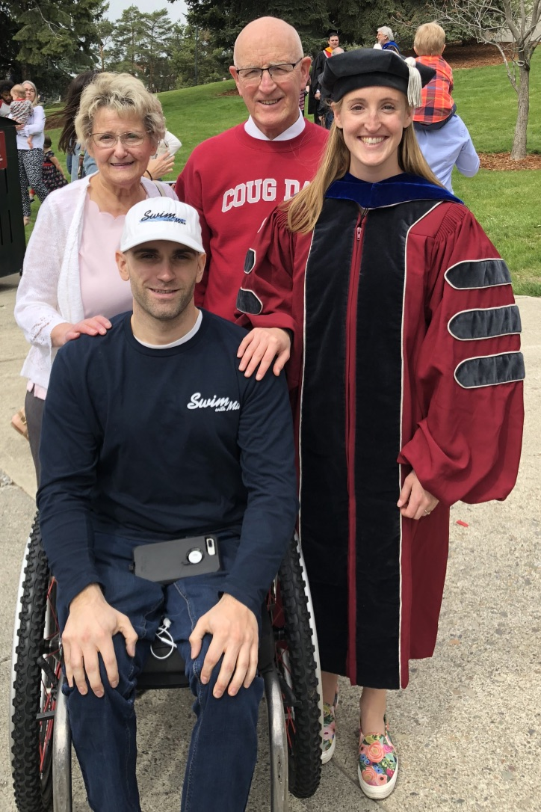
Ron with his wife, son, and daughter at his daughter’s graduation from Washington State University at Pullman.

Ron as a helicopter pilot in the Marine Corps Reserves at the controls of a UH-1N twin-engine Huey helicopter.

- Certificated High School Math Teacher, Washington State and California;
- Substitute taught nearly every school day since 2009; all grades K-12, nearly all subjects – including bilingual and special ed – in 7 Washington State school districts and both public and charter schools in inner-city Los Angeles;
- Two MS Degrees, one in Chemical Engineering from the University of Washington;
- Vietnam Veteran: Flew helicopters for the US Marine Corps in Vietnam during the Vietnam War; retired from the US Marine Corps Reserves as a Lt. Colonel;
- Former School Bus Driver.

Married to wife Deborah since 1983; two adult children, one son (Gonzaga graduate) and one daughter (WSU graduate).

www.higgins4spi.com
educate@higgins4spi.com
PO Box 4702 West Richland, WA 99353
509-873-2978 (cell)
Paid for by Citizens for Ron Higgins

